Lab 5: Binary Trees

Albert Cho, Hung Manh, An Nguyen

14 June 2021

Lab Code:

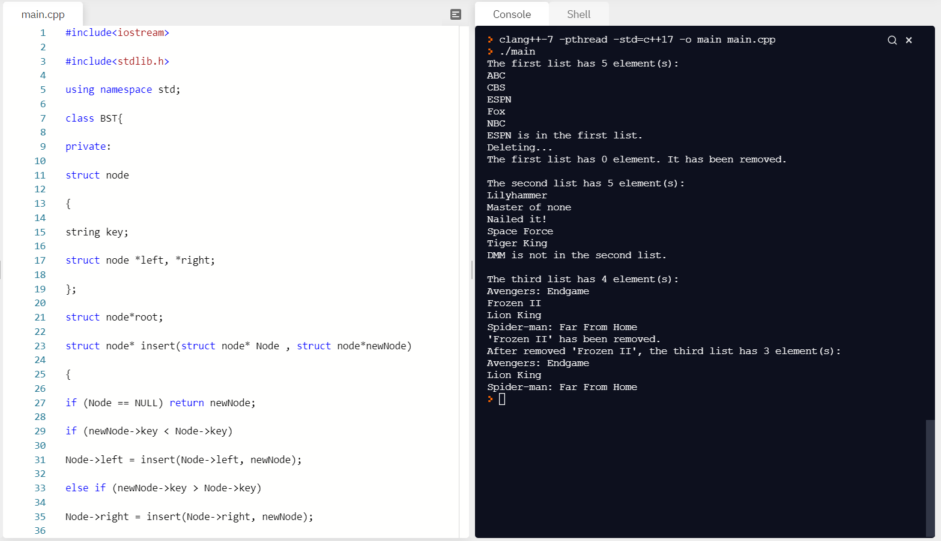

The structure is alphabetical because there's a function to sort the strings by alphabetical order, we can improve in the future by letting the user chose which way they want to print the tree.

Conclusion:

The objective of this lab was to create an implementation of a Binary Search Tree. This is important to this course because it is used to store piece of data and can be searched efficiently. It can be used in career of engineering to insert a key value if it is in the tree, or remove a key value.

Team Evaluation: We all contributed to the coding. The grade for all of us should be evenly distributed.